YOU ARE INVITED!

**BIPOC People with Disabilities & Deaf People**

The Nunavummi Disability Makinnasuaqtiit

Society invites you to a webinar and dialogue

for National Accessibility Week 2024!

Image Description: Logo Nunavummi Disability Makinnasuaqtiit Society

**When:** Tuesday May 28, 2024

**Time:** 10:00-12:00 PM PT

11:00-1:00 PM MT

12:00-2:00 PM CT

1:00-3:00 PM ET

2:00-4:00 PM AT

**RSVP:** [d.rajan@irisinstitute.ca](mailto:d.rajan@irisinstitute.ca)

**Zoom Link:** <https://us02web.zoom.us/j/88369679597>

Meeting ID: 883 6967 9597

One tap mobile

+16475580588,,88369679597# Canada

+17789072071,,88369679597# Canada

Learn about the issues of diverse BIPOC people with disabilities and Deaf people communities and join in on the discussion! Facilitator - Doris Rajan, IRIS Institute; Guest Panel - Kelly Johnson, Lana Pahkopewin, Andrea Zachary, and Bee Soh.

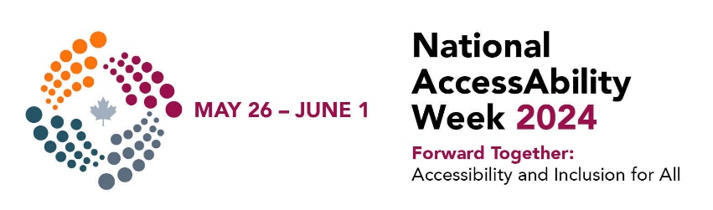

Image Description: Logo, National Accessibility Week 2024

ASL and CART (real time captioning) available. Please let us know if you need a accessible copy of the PowerPoint presentation before the event!